# <frame> or <iframe> elements do not have a title

May 2, 2019 • Updated Sep 19, 2019

Appears in: [Accessibility audits](https://web.dev/lighthouse-accessibility)

Users of screen readers and other assistive technologies rely on frame titles to describe the contents of frames. Navigating through frames and inline frames can quickly become difficult and confusing for assistive technology users if the frames are not marked with a title attribute.

## How the Lighthouse frame title audit fails [#](https://web.dev/frame-title/?utm_source=lighthouse&utm_medium=devtools#how-the-lighthouse-frame-title-audit-fails)

Lighthouse flags <frame> and <iframe> elements that don't have titles:

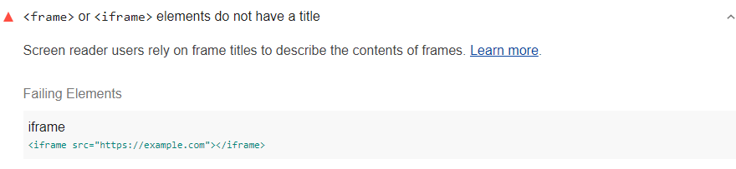

The Lighthouse Accessibility score is a weighted average of all the accessibility audits. See the [Lighthouse accessibility scoring](https://web.dev/accessibility-scoring) post for more information.

## How to add titles to frames and iframes [#](https://web.dev/frame-title/?utm_source=lighthouse&utm_medium=devtools#how-to-add-titles-to-frames-and-iframes)

Provide unique and descriptive title attributes for all frame and iframe elements.

Additionally, best practice is to give the enclosed document a title element with content identical to the title attribute. For example:

<iframe title="My Daily Marathon Tracker" src="https://www.mydailymarathontracker.com/"></iframe>

## Tips for creating descriptive frame titles [#](https://web.dev/frame-title/?utm_source=lighthouse&utm_medium=devtools#tips-for-creating-descriptive-frame-titles)

* As previously mentioned, give the enclosed document a title element with content identical to title attribute.
* Replace placeholder titles such as "untitled frame" with a more appropriate phrase.
* Make each title unique. Don't duplicate titles, even if they are similar.

**Be Sure to Provide Titles for Iframes**

Iframes usually do not cause accessibility issues for users as long as the iframe has a title and the structure of a document within the iframe make sense within the container document. When an iframe is given a meaningful title, screen reader users can pull up a list of frames and identify the content or purpose of the iframe based on its title. Without a meaningful name, a screen reader user may just hear "frame", the file name, path of the iframe, or an unhelpful name like "javascript".

**Always Provide a Title for an Iframe**

For iframes that have meaningful content, provide a title using the title attribute.

<iframe title="Campus Tour" src="campustourvideo.html"></iframe>

For iframes that contain non-readable content, like JavaScript, provide a title to pass automated tests, but be sure to hide the content altogether from screen reader users using aria-hidden="true".

<iframe title="Intentionally blank" src="noreadablecontent.com" aria-hidden="true"></iframe>

**Make Sure Documents Within Iframes Have Titles, Too**

Some screen readers may read a document's title in the iframe instead of the title attribute on the <iframe> tag, if the document's title is available. A best practice would be to use both a title attribute and the <title> tag that matches each other to make sure the same title is read across various screen readers.

### What is an iFrame?

An iFrame an HTML component that allows you to embed content from other web pages or URLs into your web page. Common examples of content that may be embedded into a web page using an iFrame are videos, documents, charts or widgets, and forms. You can actually embed an entire web page into another web page using an iFrame!

iFrames can look distinct from the page on which they’re embedded where it is obvious that something is embedded on the page from another source, or they can be styled to look seamless so it is not obvious that the embedded element is coming from a different URL rather than being added directly on the page.

iFrames have HTML structure, at their simplest, containing <iframe> tags like this:

<iframe src="https://supmti.ac.ma/"></iframe>

The iFrame src attribute (source) tells the iFrame where to get its content from. iFrames can include a number of other attributes including dimensions like height and width. Here is an example of an iFrame that loads the home page of our website:

And here is the code that is used to load the iFrame shown above:

<iframe src="https://supmti.ac.ma/" title="Ecole Superieure Sup MTI – Reconnu par l’etat" width="100%" height="400"></iframe>